PROFILES
CBHS students have moved on to become some of New Zealand's most highly regarded leaders, academics, sportsman, and community servants. We'd like to thank and recognise the achievements of our Old Boys:
More profiles will be added to this section and we invite community members to submit profiles of Old Boys for publication.
- Charles Adams (born 1 October 1870) Surveyor, Astronomer, Seismologist
- Geoffrey Alley (born 4 February 1903) Farmer, All Black, Librarian
- Rewi Alley (born 2 December 1897) Writer, Social Reformer, Teacher, Peace Activist
- Bernard Aston (born 9 August 1871) Agricultural Chemist, Botanist
- Anson William Austin (born 9 July 1940) Opera Singer
- William Alexander (born 20 July 1882) Poet, Newspaper Editor
- John Bartrum (born 24 May 1885) Geologist
- Clarence Beeby (born 16 June 1902) Educationalist
- Horace Belshaw (born 9 February 1898) Teacher, Economist, University Professor
- Phillip Blakeley (born 3 April 1915) Electrical Engineer
- Cecil Blazey (born 21 July 1909) Businessman, Military Administrator, Sports Administrator
- Anthony Patrick Francis Browne (born 16 March 1948) Diplomat
- William Burn (born 17 July 1891) Military Aviator
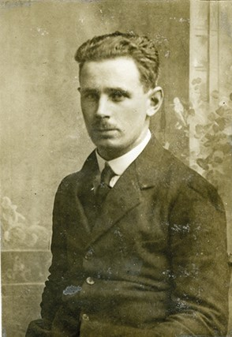
- James Burrows (born 13 July 1904) Soldier, Teacher, Sportsman
- Francis Callaghan (born 15 April 1891) Teacher
- David Francis Caygill CNZM (born 15 November 1948) Cabinet Minister
- Oswald Cheesman (born 13 September 1913) Musician
- Russell Clark (born 27 August 1905) Artist
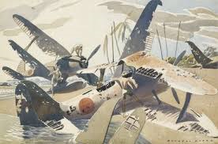
- Charles Cotton (born 24 February 1885) Geologist, Geomorphologist, University Professor, Writer
- Hugh Cordery (born 27 March 1880) Customs Official
- Allen Curnow (born 17 June 1911) Journalist, Academic
- Robert Deans (born 19 February 1884) All Black
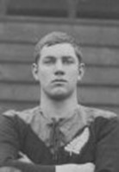
- Fredrick de la Mare (born 6 August 1877) Lawyer, Educationalist
- Alan Duff (born 26 October 1950) Author
- Roger Duff (born 11 July 1912) Ethnologist, Museum Director
- George Forbes (born 12 March 1869) Prime Minister
- Theodore Gibbs (born 3 February 1896) Business Man, Political advisor
- William Gilling (born 28 December 1891) Musician, scholar and a gentleman

- Jason Gunn (born 26 December 1968) Radio and television presenter
- Andrew Henderson (born 25 May 1879) Illustrator, Cartoonist, Pacifist
- Charles Hercus (born 13 June 1888) Doctor
- Montague Harry Holcroft (born 14 May 1902) Journalist, Editor
- Elric James Hooper (born 30 January 1936) Actor
- Leonard Isitt (born 27 July 1891) Military Aviator and Leader
- Sir Howard Kippenberger (born 28 January 1897) Lawyer, Military Leader, Historian
- Fredrick Kissel (born 27 March 1881) Engineer
- David Low (born 7 April 1891) Cartoonist, Broadcaster
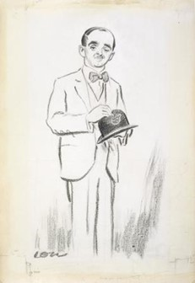
- Selwyn Maister QSM (born 24 May 1946) Rhodes Scholar, Olympian, Teacher
- Sir Leonard Monk Isitt (born 27 July 1891) Air Vice Marshall
- Archibald Nicoll (born 14 June 1886) Artist
- Fredrick Page (born 4 December 1905) University professor, Pianist
- Robert Page (born 23 November 1897) Pacifist, Industrial Chemist
- Peter Phipps (born 7 December 1908) Naval Officer
- Maui Pomare (born 13 January 1876) Ngati Mutunga and Ngati Toa; Medical Officer, Maori Health Reformer, Politician
- Hugh Somerset (born 29 August 1895) Teacher, Writer
- Robert Speight (born 2 October 1867) Geologist
- Bill Sutton (born 1 March 1917) Artist
- Hugh Riminton (born 1961) Journalist
- Henry Thacker (born 20 March 1870) Doctor, Politician, Sports Administrator
- Keith Thiele (born 25 February 1921) WWII Pilot
- James Thorn (born 1 June 1882) Trade Unionist, Journalist, Editor, Politician, High Commissioner
- Wilfred Wallis (born 15 May 1891) Orthapedic Surgeon
- Spencer Westmacott (born 10 November 1885) Farmer, Soldie
- Glen Wilson (born 29 December 1942) Psychologist
- Joseph Wilson (born 14 July 1894) Soldier, Public Servant, Diplomat
- Niel Wright (born 30 September 1933) Poet

