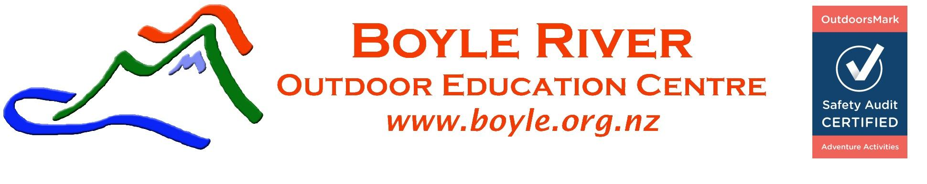
STUDENT GEAR LIST – 3 days

PUT YOUR NAME ON YOUR GEAR AND CLOTHES!

Use this sheet as a check list. Items in italics are available to supplement from the Centre

PACKED |  | CLOTHES
 | 3 | Polypro/wool thermal tops-can layer these
 | 2 | Polypro/wool thermal long johns
 | 2 | Warm jerseys (fleece / wool)- can layer these
 | 2 | Pairs shorts
 | 1 | Pairs warm long trousers/track pants for activities - NO JEANS or COTTON
 | 3 | Changes of underwear
 | 1 | Pyjamas or similar
 | 3 | Pairs socks (thick woollen )
 | 1 | Waterproof parka
 | 1 | Waterproof over pants
 | 1 | Pairs gloves or mittens (fleece / wool / polypro)
 | 1 | Beanie (fleece / wool / polypro)
 | 1 | Sun hat
 | 2 | Pairs strong, sturdy shoes/trainers, boots (suitable for wet, muddy conditions: a must for winter)
 | 1 | Swim gear
 |  | Changes of clothes for travel/evenings, including footwear (inside)
PACKED |  | GEAR
 | 1 | Towels
 | 1 | Large black rubbish bags
 |  | Toiletries
 |  | Warm sleeping bag
 | 1 | Bed Roll
 |  | Pillow
 | 2 | Packs – 1 Day Pack and 1 big pack ( if you dont have this then the boyle have a few spare packs)
 |  | Torch and spare batteries
 |  | Cards / Games
 |  | Water bottle
 |  | Sunglasses in protective container
 |  | Sun screen and Insect repellent
 |  | Bowl and spoon
 |  | Personal first aid kit (plasters, strapping tape) and personal medication
 |  | Camera (optional)
 |  | 1 Cut lunch for the first day
 |  | Home baking / Supermarket Baking to share this is important for group culture
No radios or ipods allowed, however musical instruments are welcome. Cell phones don’t work up here.

SOME COMMENTS ON CLOTHING

Some of the best experiences happen in challenging conditions, so you need to have suitable
clothing for all weather! If you do not have anything on the gear list try and borrow it rather than
buy expensive items. It is best to come organized and prepared. You can also borrow the marked items
from the Boyle if you do not have your own.

Clothing is most effective when we wear multiple layers, which trap heat and can be removed easily when you get hot. Remember warmth is provided by the material's ability to trap body heat, the material itself doesn't provide the warmth.

FIRST LAYER - polypropylene/wool against the skin. Top and long johns, depending on the weather and
woollen socks. These fabrics help wick the water away from the skin to help keep you warm. Cotton is no good as, unlike polypro, it draws heat away from the body when wet and makes you cold or possibly hypothermic. You can wear multiple polypro/wool layers.

SECOND LAYER - one or two layers of fleece/wool for the top and long pants/polypro and shorts for the bottom if the weather's cold. These layers insulate your body heat and do not feel cold if they get wet. Don't forget a beanie and gloves! Jeans are not suitable, except in the lodge, as they are extremely heavy when wet and restrict movement. They are also made of cotton and remove heat from the body when wet. T-shirt, shorts sunglasses and a sun hat if the weather is hot – you need to cover up as the sun is powerful up here.

THIRD LAYER - The water proof/wind proof layer. Jacket and over-trousers that are able to withstand a good continuous dumping of rain. Goretex, Reflex and PVC are best. Nylon windbreakers and anything filled with dacron or down are generally NOT waterproof. If you are unsure about your jacket go outside with a bucket of water and test it before you come! Or you can borrow one from us!

FOOTWEAR – It is important to have strong, sturdy footwear as we are often walking on uneven and slippery ground in the bush and mountains. Boots are good as they provide ankle support, but sturdy trainers are fine for many activities, providing they are done up tightly for support. Boots are best for the winter months.
Loose-fitting skate or flat shoes do not do the job!

FOOD - Remember food is essential to provide energy and warmth for a busy programme.
Bring home baking and plenty of scroggin, muesli bars dried fruit etc to have as treats.
Fluid intake is very important to avoid dehydration. Water is best - so eat & drink lots!

For more information refer to Mountain Safety Council “Bushcraft Manual”

Private Bag 55002, Orchard Road, Christchurch, 8154
Ph/Fax: 03 315 7082 Email: info@boyle.org.nz

